**Card Sorting**

Link to the study:   
*https://mbe4ng17.optimalworkshop.com/optimalsort/y03te23y*

**Card Sorting Technique: Open Card Sorting**

**Participants: 6**

**Number of Cards: 29**

**Tool Used: Optimal Workshop**

**What is Card Sorting**

* A card sort is a user centered design method for increasing a system’s findability.
* The process involves sorting a series of cards, each labeled with a piece of content or functionality, into groups that make sense to users or participants
* Card sorting answers the main question: Are people finding what they came for?
* Who best to answer this question other than the user himself
* Our goal for card sorting is to validate the categories and to discover new categories

**Cards:**

|  |
| --- |
| View Course Catalog |
| View Transcripts |
| Bookstore |
| Forgot Password |
| Login |
| Course Registration |
| Loan/view borrowed books |
| Apply for Job |
| View Gradebook |
| My Schedule |
| My Finance Account |
| Employment Forms |
| View Bills |
| Reserve a room |
| View status of applied jobs |
| Find A Job |
| Direct Deposit Forms |
| Financial Counseling |
| Contact Us |
| Lecture Material |
| View Financial Aid status |
| Lecture Recording |
| View lecture material |
| My Profile |
| View emails |
| Search for library room |
| Health Insurance Requests |
| Apply for Financial Aid |
| Fill timesheet |

**Results**

**Qualitative Results:**

User comments

* Did not understand where to place student forms
* Card name Payments was not clear

**Quantitative Analysis:**

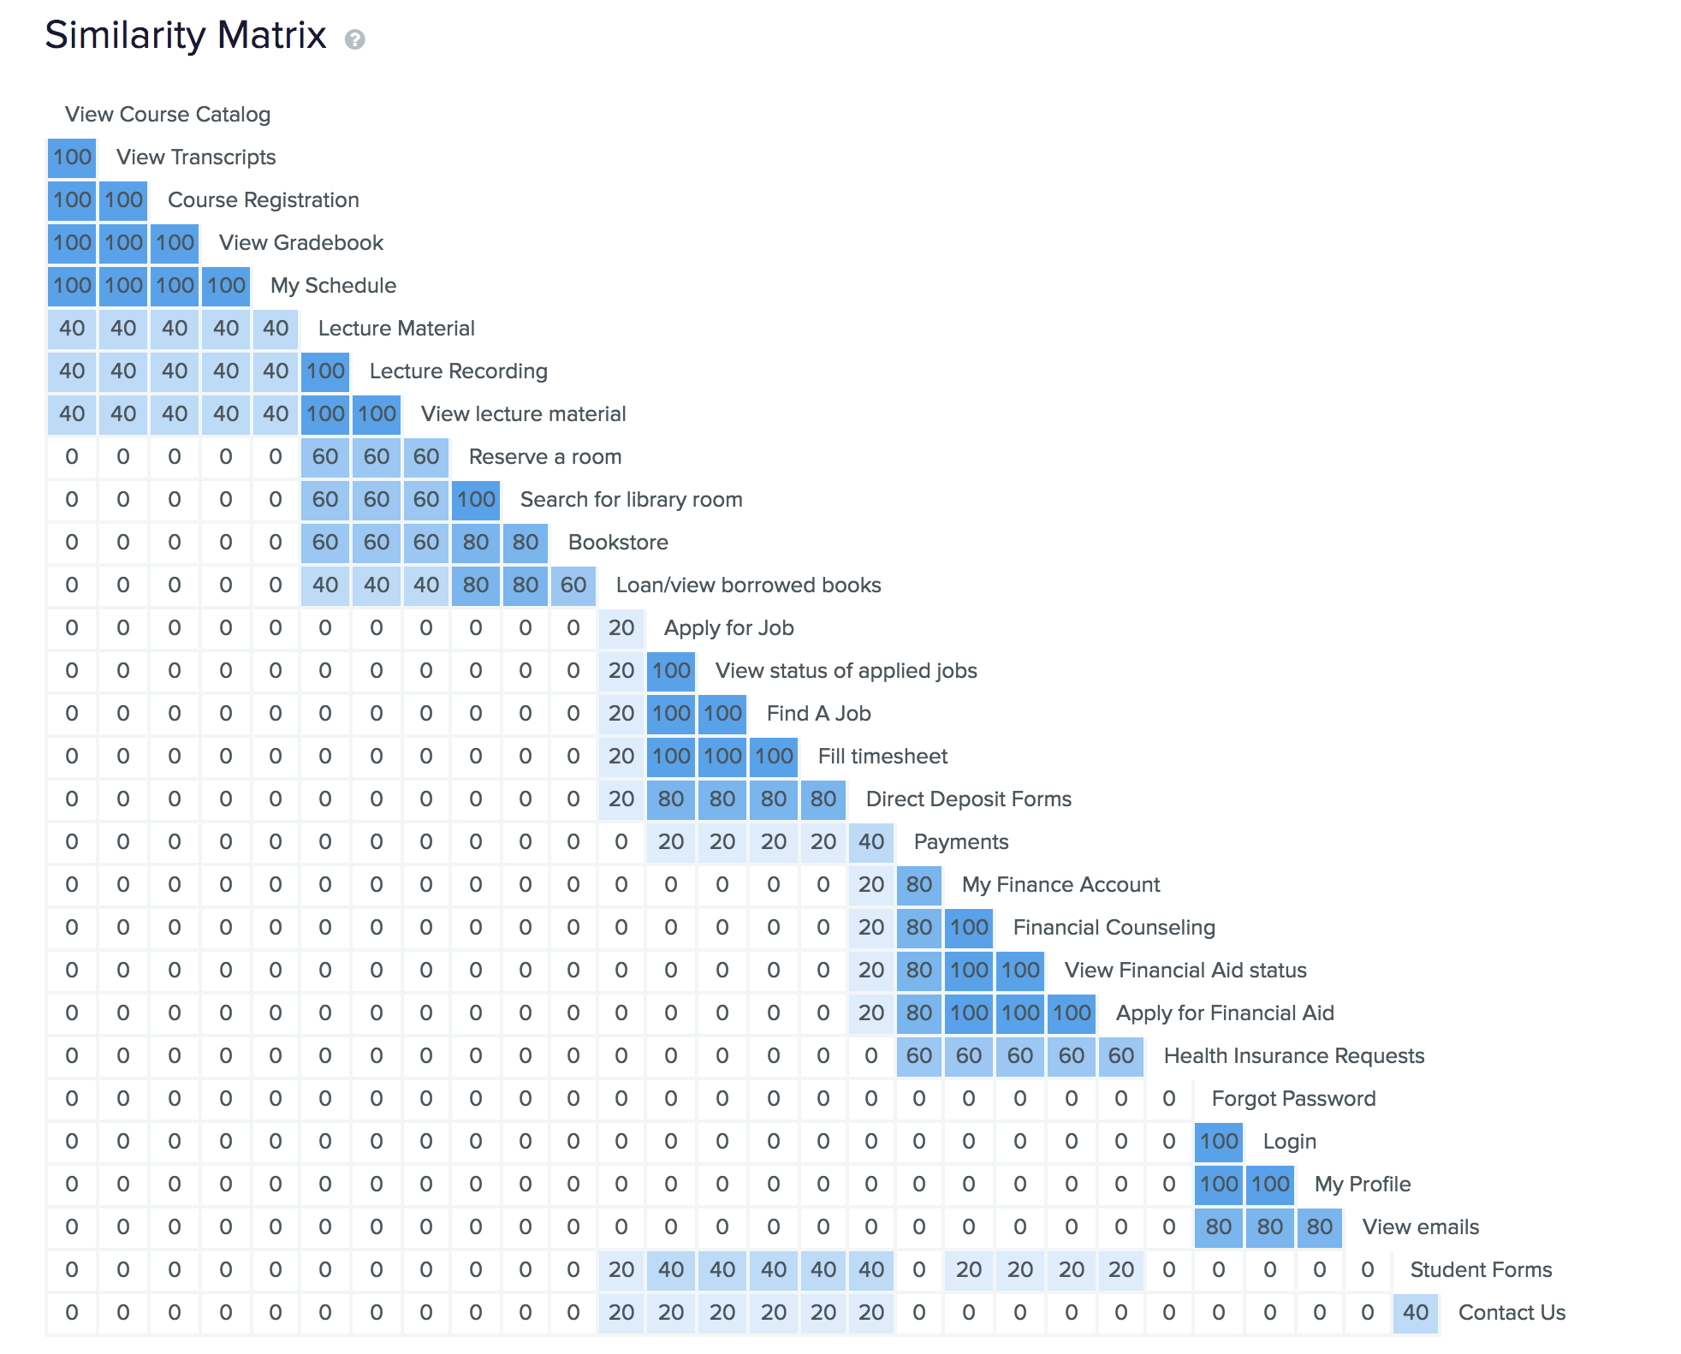

**Hierarchical Cluster analysis: (Dendrogram)**

